EMPLOYEE ATTRITION ANALYSIS
Identifying the Drivers of Employee Turnover at IBM

Project Report

Prepared By:
Shourjo Ghosh (iimsi_edge_2511120)
Kartik Mallya (iimsi_edge_2511101)
Supriya Pani (iimsi_edge_2511131)
Devarsh Shah (iimsi_edge_2511197)
Prem (iimsi_edge_2511016)

Date: July 22, 2026
Dataset: IBM HR Employee Attrition Data

Table of Contents
Table of Contents 1
2. Executive Summary 1
3. Business Problem 1
4. Dataset Description 1
4.1 Source and Size 1
4.2 Data Dictionary 1
4.3 Data Quality Notes 1
4.4 Charts and Interpretation……………………………………………………………………………………………………………….1
5. Methodology 1
6. Analysis & Findings 1
6.1 The analytical workflow 1
6.2 Exploratory data analysis 1
6.3 Ranking the predictor variables 1
6.4 Final selection of variables 1
6.5 Splitting the data for training and testing 1
6.6 Logistic regression model configuration 1
6.7 J Prediction output 1
6.8 Model performance 1
6.9 Confusion matrix 1
6.10 ROC curve analysis 1
6.11 Coefficient analysis 1
6.12 Nomogram interpretation……………………………………………………………………………………………………………1
6.13 Improving detection through class balancing……………………………………………………………………………….1
6.14 Summary of findings…………………………………………………………………………………………………………………….1
7. Business Recommendations 1
7.1 Quick Summary 1
7.2 How Good is Our Data Tool? 1
7.3 Main Reasons People Leave or Stay 1
7.4 Action Plan: What We Should Do 1
7.5 Next steps 1
8. Conclusion 1
9. References 1

2. Executive Summary
IBM operates in approximately 170 countries across the computing, software, and hardware industries, and depends heavily on skilled, experienced employees as a core competitive asset. Losing trained staff to attrition is costly in terms of recruitment, onboarding, lost productivity, and institutional knowledge. This project analyzes an HR dataset of 1,470 employees to identify the factors most strongly associated with attrition.
The analysis finds an overall attrition rate of 16.1%, with turnover concentrated among younger, lower-tenure, lower-income, and single employees. Statistically significant relationships (p < 0.05) were found between attrition and Age, Monthly Income, Distance From Home, Years at Company, Department, Education Field, Marital Status, Work-Life Balance, Job Satisfaction, and Environment Satisfaction. A logistic regression model built on these variables achieved 85.03% accuracy and an AUC of 0.745, confirming that the identified factors carry real predictive signal.
Key recommendations include targeted retention programs for early-career and single employees, compensation review for at-risk salary bands, closer monitoring, and continued investment in work-life balance and job satisfaction initiatives.

3. Business Problem
In today's highly competitive business environment, employees are one of an organization's most valuable resources. While companies invest heavily in recruiting, training, and developing talented individuals, retaining those employees has become an increasingly difficult challenge. Employee attrition, which refers to employees leaving an organization either voluntarily or involuntarily, is a common issue faced by businesses across industries. Although some level of employee turnover is unavoidable, consistently high attrition rates can create serious operational, financial, and strategic problems for an organization.
For a global technology company such as IBM, employee retention is particularly important because its success depends largely on the knowledge, skills, and experience of its workforce. IBM operates in fields such as software development, cloud computing, artificial intelligence, consulting, and enterprise technology solutions. These industries require highly skilled professionals whose expertise is developed over several years. When experienced employees leave, the company not only loses technical knowledge but also valuable client relationships, project experience, and organizational understanding that are difficult to replace.
One of the most immediate consequences of employee attrition is the financial cost associated with replacing employees. Hiring a new employee is a lengthy and expensive process that involves advertising job vacancies, screening applications, conducting interviews, onboarding new hires, and providing technical and organizational training. Even after recruitment, new employees typically require several months before they reach the same level of productivity as experienced staff members. During this transition period, organizations often experience reduced efficiency and increased operational costs.
The impact of attrition extends beyond direct financial expenses. When skilled employees leave, ongoing projects may be delayed, workloads increase for remaining team members, and overall team productivity can decline. Employees who continue working within the organization may experience additional pressure while covering vacant positions, which can reduce morale and increase the likelihood of further resignations. This creates a cycle where high attrition contributes to even greater employee dissatisfaction, making workforce management increasingly difficult.
Customer satisfaction can also be affected by employee turnover. In service-oriented organizations like IBM, employees frequently work directly with clients and develop long-term professional relationships. When experienced employees leave during active projects, customers may experience delays, inconsistent service quality, or communication gaps. Such disruptions can weaken client trust and potentially affect future business opportunities. Therefore, managing employee attrition is not only an internal human resource concern but also an important factor in maintaining customer relationships and organizational reputation.
Understanding why employees leave is far from straightforward because attrition is rarely caused by a single factor. Instead, it usually results from a combination of personal, professional, and organizational circumstances. Factors such as age, salary, job role, overtime, work-life balance, career growth opportunities, years of experience, commuting distance, business travel, education level, department, and job satisfaction can all influence an employee's decision to stay with or leave an organization. These variables often interact with one another, making it difficult for managers to identify employees who may be at risk of leaving using traditional reporting methods alone.
Many organizations rely on historical reports or employee exit interviews to understand attrition. While these methods provide useful information, they are reactive rather than proactive. By the time an employee resigns and participates in an exit interview, the organization has already lost valuable talent. This limits the company's ability to take preventive action. Businesses therefore require more predictive approaches that enable them to identify potential attrition risks before employees decide to leave.
This is where data analytics and machine learning provide significant value. By analyzing historical employee data, machine learning algorithms can identify hidden patterns and relationships that may not be immediately visible through manual analysis. Classification models can be trained using employee records to predict whether an employee is likely to remain with the organization or leave in the future. These predictions allow Human Resource (HR) departments to intervene early by offering career development opportunities, adjusting workloads, improving work-life balance, reviewing compensation packages, or addressing workplace concerns before attrition occurs.
The IBM Employee Attrition dataset provides an opportunity to study this business problem using real-world employee information. The dataset contains demographic, professional, and workplace-related variables that can be used to understand the factors influencing employee turnover. By developing predictive classification models and evaluating multiple machine learning algorithms, organizations can identify the most effective approach for predicting employee attrition. Hyperparameter tuning further improves model performance by optimizing algorithm settings, resulting in more reliable predictions.
Ultimately, the business problem addressed in this project is not simply predicting whether an employee will leave the organization. The broader objective is to help organizations make informed, evidence-based human resource decisions that improve employee retention, reduce recruitment and training costs, maintain business continuity, preserve organizational knowledge, and strengthen long-term organizational performance. By transforming employee data into actionable insights, predictive analytics enables organizations such as IBM to shift from reacting to employee resignations toward proactively building a more stable, productive, and engaged workforce.

4. Dataset Description

4.1 Source and Size
The dataset used in this project is the IBM HR Analytics Employee Attrition dataset. It contains 1470 employee records and 13 variables. The dataset is widely used for HR analytics and machine learning to predict employee attrition. The dependent variable is Attrition, while the remaining variables describe employee demographics, job role, satisfaction and work-related characteristics.

Key Points
- Total Records: 1470
- Total Variables: 13
- Target Variable: Attrition (Yes/No)
- No missing values detected.
- Suitable for classification modelling.

4.2 Data Dictionary
Variable | Type | Description
Age | Numeric | Age of the employee in years
Attrition | Categorical (Yes/No) | Whether the employee left the company (target variable), YES- 16% and NO- 84%
Department | Categorical | Department the employee works in (Sales – 30%, R&D – 65%, HR – 4%)
DistanceFromHome | Numeric | Distance between home and workplace (i.e between 1 to 29 miles)
Education | Ordinal (1–5) | Education level, 1=Below College 2- College; 3-Bachelor; 4-Master; 5-Doctor
Education Field | Categorical | Field of education (Life Sciences, Medical, Marketing, etc.)
Environment Satisfaction | Ordinal (1–4) | Satisfaction with work environment, 1=Low ; 2-Medium; 3-High; 4-Very High;
Job Satisfaction | Ordinal (1–4) | Satisfaction with job, 1=Low ; 2-Medium; 3-High; 4-Very High;
Marital Status | Categorical | Single – 32%, Married – 46%, or Divorced – 22%
Monthly Income | Numeric ($) | Monthly salary of the employee
Num Companies Worked | Numeric | Number of companies the employee has worked at previously
Work Life Balance | Ordinal (1–4) | Perceived work-life balance, 1=Bad ; 2-Good; 3-Better; 4-Best;
Years At Company | Numeric | Total years the employee has spent at the company

4.3 Data Quality Notes
- No missing or null values were identified.
- Dataset contains valid employee records.
- Attrition variable is imbalanced (majority = No).
- Categorical variables are consistently labelled.
- Numeric fields (Age, Monthly Income, DistanceFromHome, Years At Company, etc.) fall within plausible business ranges with no evident outliers or data-entry errors.
- Dataset is suitable for machine learning after preprocessing.

4.4 Charts and Interpretation

Figure 1: Age Distribution
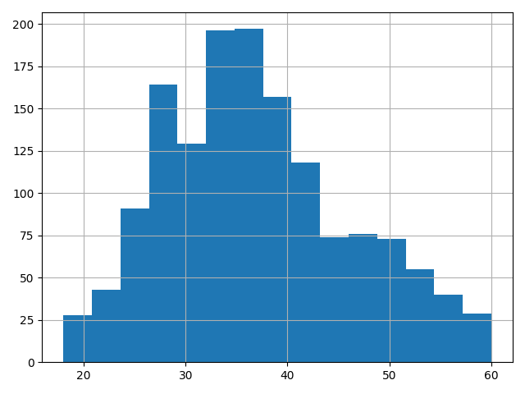

Interpretation:
This visualization shows Distribution of Age across IBM HR dataset

Figure 2: Attrition Distribution
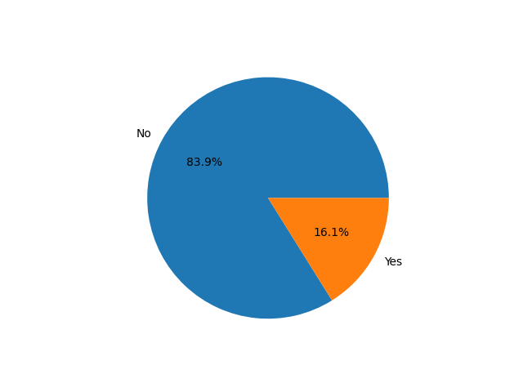

Interpretation:
This visualization summarizes an important characteristic of the IBM HR dataset and supports understanding of employee attrition patterns.

Figure 3: Employees by Department
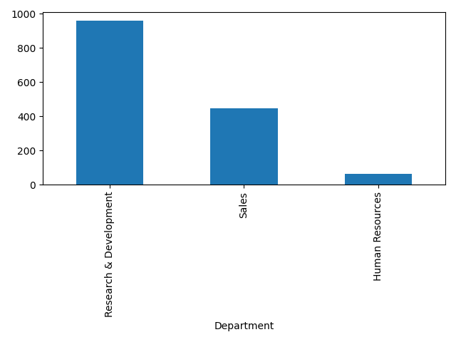

Interpretation:
This visualization shows Distribution of employee department across IBM HR dataset.

Figure 4: Distance from Home
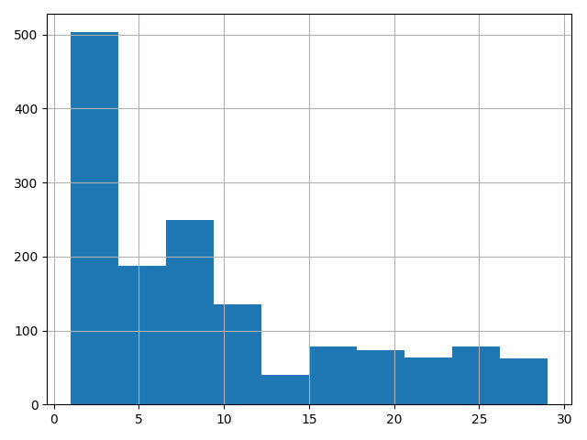

Interpretation:
This visualization shows Distribution of employee Distance from Home across IBM HR dataset.

Figure 5: Education
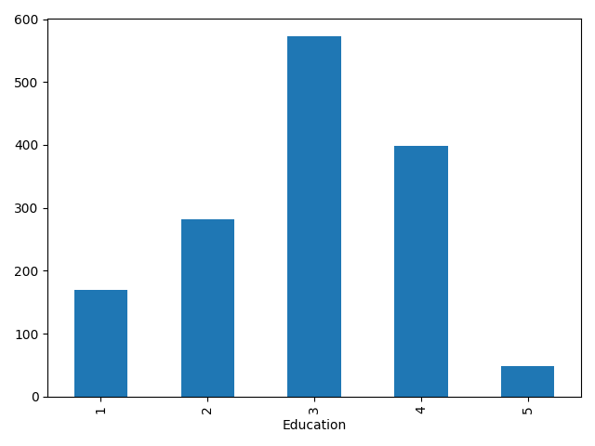

Interpretation:
This visualization Shows the distribution of employee Education level across IBM HR dataset.

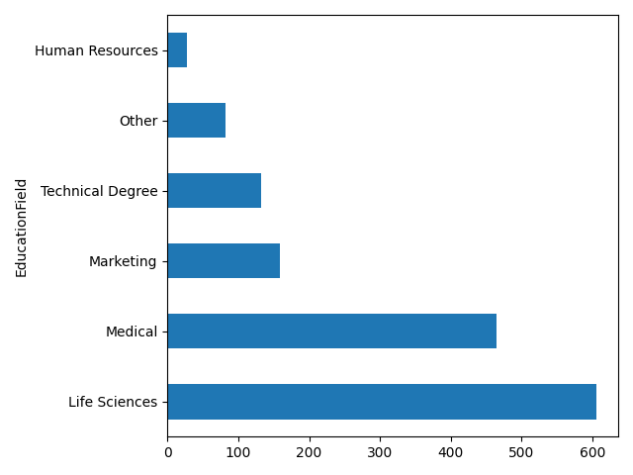
Figure 6: Education field

Interpretation:
This visualization Shows the distribution of employee Education Field across IBM HR dataset.

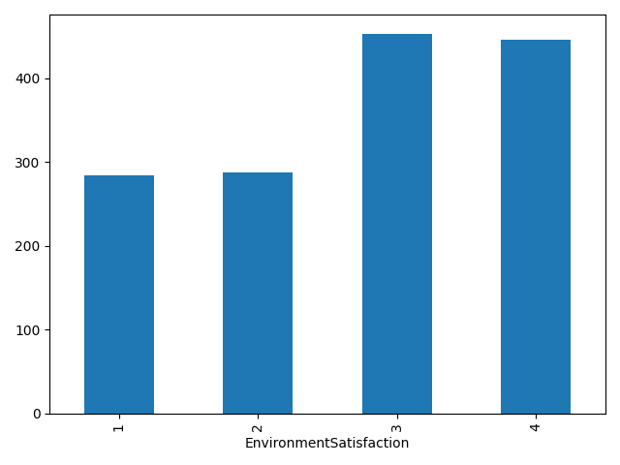
Figure 7: Environment Satisfaction

Interpretation:
This visualization Shows the distribution of employee Environment Satisfaction across IBM HR dataset.
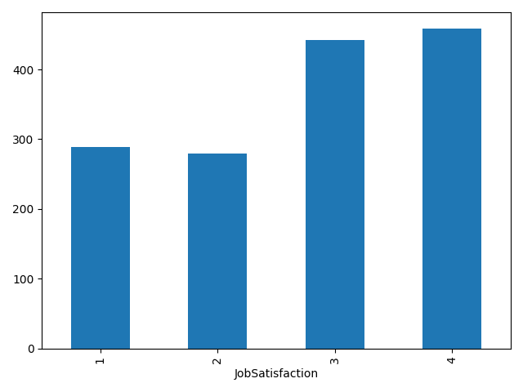
Figure 8: Job Satisfaction

Interpretation:
This visualization Shows the distribution of employee Job Satisfaction across IBM HR dataset.
Figure 9: Martial Status
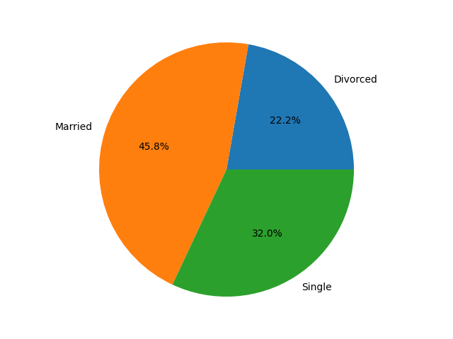

Interpretation:
This visualization Shows the distribution of employee Marital Status across IBM HR dataset
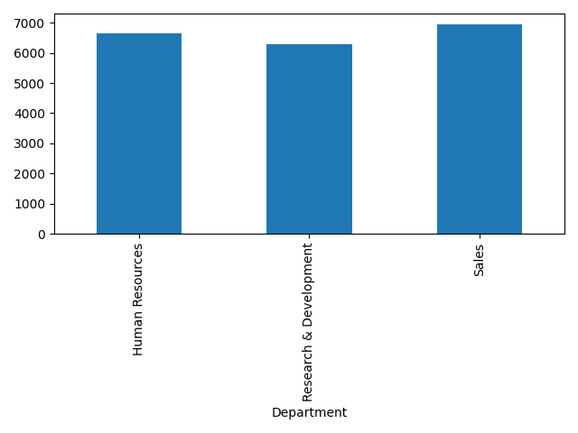
Figure 10: Average Monthly Income

Interpretation:
This visualization Shows the distribution of employee Average monthly income of different departments across IBM HR dataset

5. Methodology

The analysis used is Logistic Regression analytics as the dependent variable (Attrition) is categorical (Yes/No) and we need to predict the probability of a specific outcome.
Steps followed in Orange:
- Data Cleaning & Validation: Checked for missing values, verified data types, and confirmed category levels for all categorical variables.
- Selecting Columns: Removing columns with high significance of variable (p-value>0.05). Here PSPP is used to check the significance of variable.
- Data Sampling: Dividing the dataset into training and testing in 70:30 ratio.
- Building Predictive Model on Training Data: Trained a Logistic Regression (on the 70% training data) to quantify the direction and relative strength of each factor's influence on attrition.
- Test the Model in Testing Data: To test how well attrition can be predicted from the available variables (on the 30% testing data).

Mathematical model of Logistic Regression: $\log\left(\frac{y}{1-y}\right)= β_{0}+ β_{1}x_{1}+ β_{2}x_{2}+ β_{3}x_{3}…….$

Where: y is dependent variable
$β_{0}, β_{1}, β_{2}, β_{3}…….$ are coefficients
And $x_{1}, x_{2}, x_{3}…….$ Are independent variables

ORANGE WORK FLOW

6. Findings and Analysis
This section reports the results of the analysis of the IBM HR Analytics dataset. It follows the sequence of the Orange Data Mining workflow, beginning with exploration of the raw employee records, moving through variable selection and model building, and ending with the evaluation results that the recommendations in the next section rest on. Each stage is shown with its corresponding orange output so that the figures can be traced back to the software.

6.1 The analytical workflow
The complete workflow was assembled in Orange Data Mining. The CSV file was loaded and inspected, variables were assigned roles, the data was visually explored, the predictor set was narrowed using ranking scores, and the records were split into training and test subsets before a Logistic Regression classifier was trained. The trained model was then fed four separate evaluation widgets: Predictions, Confusion Matrix, ROC Analysis, and a Nomogram, along with a table of model coefficients.
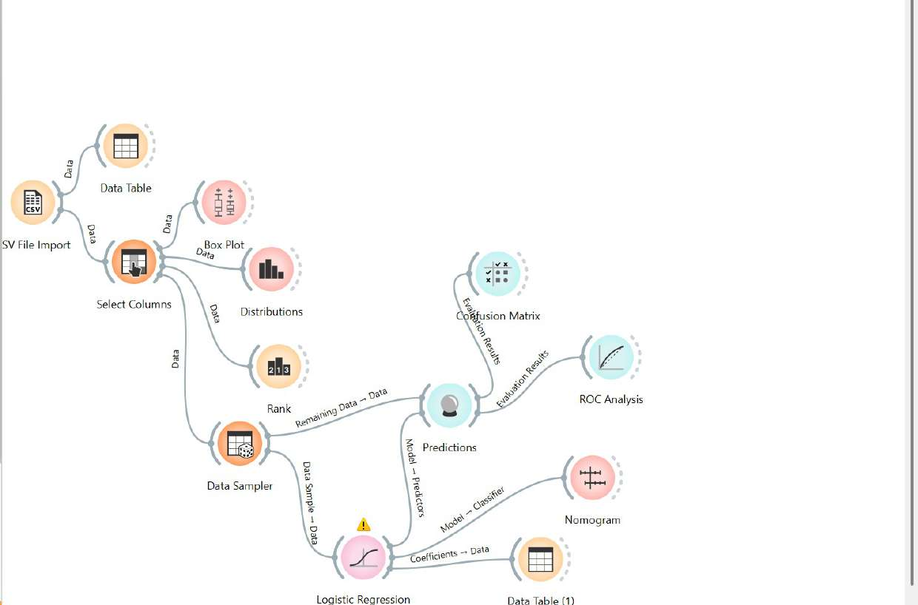
Figure 5.1: The complete Orange Data Mining workflow used for this analysis.
Building the workflow this way means that every result in this section comes from a single reproducible pipeline rather than from separate ad hoc runs. Changing any upstream setting, such as the sampling proportion, updates all downstream outputs at once.

6.2 Exploratory data analysis
Before any model was built, the Distributions and Box Plot widgets were used to examine how employees who left differ from those who stayed. The purpose at this stage was descriptive: to see which variables showed a visible gap between the two groups and were therefore worth carrying into the model.

Age
Most employees in the dataset are roughly 25 to 40 years old, with far fewer at the youngest and oldest ends of the range. Splitting the distribution by attrition shows that the proportion of leavers is highest among younger employees and declines steadily with age. Older employees appear more settled, while younger staff are more likely to move on, consistent with the pattern typically seen in early-career mobility.
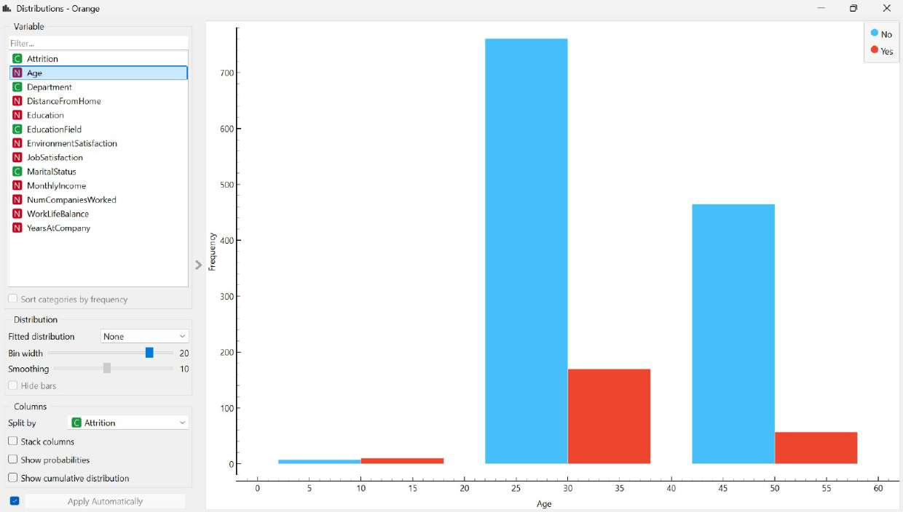
Figure 5.2: Age distribution split by attrition status (blue = stayed, red = left).

Job satisfaction
Employees reported satisfaction on a four-point scale. Levels 3 and 4 hold the largest number of employees, so the workforce is broadly satisfied. The attrition share, however, is noticeably heavier at levels 1 and 2. Around 66 of the employees who rated their satisfaction lowest had left, compared to a much smaller percentage at level 4, despite that level containing more people overall. Dissatisfaction is not the most common state in this organisation, but when it does occur, it is associated with leaving.
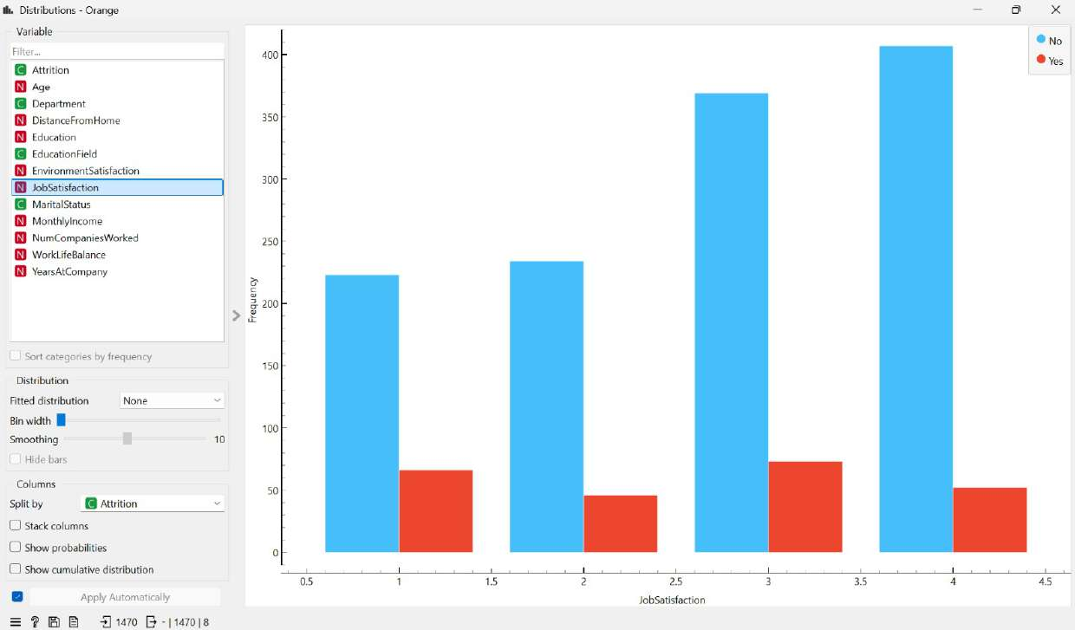
Figure 5.3: Job satisfaction distribution split by attrition status.

Monthly income
The income distribution is heavily right-skewed. A large cluster of employees sits below 5,000 per month, and the count thins out steadily across the higher salary bands. The red bars representing leavers are concentrated almost entirely in the lower salary range, becoming sparse above roughly 10,000, with very few high earners left during the period covered by the data.
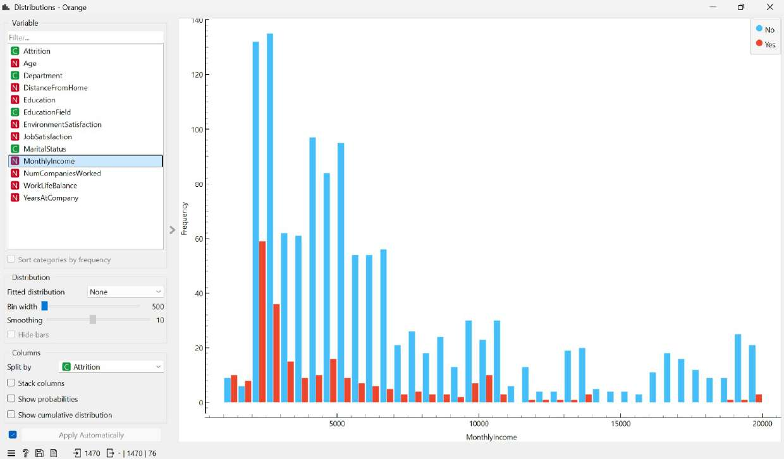
Figure 5.4: Monthly income distribution split by attrition status.

Income is compared directly between the two groups.
The Box Plot widget compares income for leavers and stayers side by side and reports a statistical test of the difference.
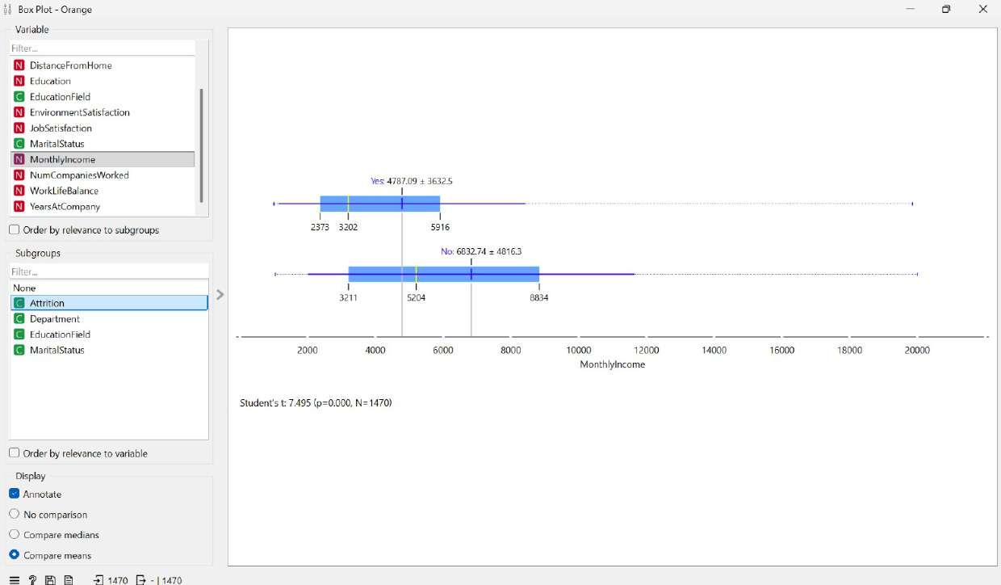
Figure 5.5: Box plot of monthly income by attrition status, with Student’s t comparison of means.
Employees who left earned a mean of 4,787.09 with a standard deviation of 3,632.5, while those who stayed earned a mean of 6,832.74 with a standard deviation of 4,816.3. The medians tell the same story: 3,202 for leavers against 5,204 for those who remained. The roughly 2,000-per-month gap is not a chance difference. Orange reports a student’s t statistic of 7.495 with a p-value of 0.000 across all 1,470 records, indicating that the difference in average income between the two groups is statistically significant at any conventional threshold.
This test matters for both the methodology and the findings. Orange does not print p-values alongside its regression coefficients, so the Box Plot comparison provides direct statistical evidence that at least the strongest predictor reliably separates the two groups, rather than by chance.

6.3 Ranking the predictor variables
The Rank widget scored all twelve candidate predictors against the target variable using Gain Ratio and Gini Decrease. Both measure how much knowing a variable reduces uncertainty about whether an employee leaves. Higher scores indicate a stronger statistical relationship with attrition.
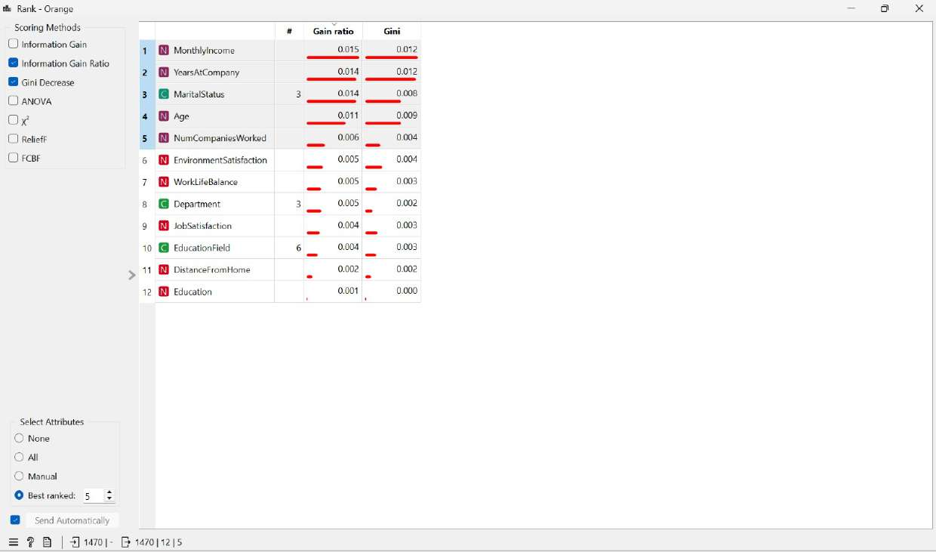
Figure 5.6: Variable ranking produced by the Rank widget.
Rank | Variable | Gain Ratio | Gini | Assessment
1 | Monthly Income | 0.015 | 0.012 | Strongest single predictor
2 | Years at Company | 0.014 | 0.012 | Strong, but overlaps with Age
3 | Marital Status | 0.014 | 0.008 | Strong categorical predictor
4 | Age | 0.011 | 0.009 | Strong demographic predictor
5 | Num Companies Worked | 0.006 | 0.004 | Moderate
6 | Environment Satisfaction | 0.005 | 0.004 | Moderate and actionable
7 | Work-Life Balance | 0.005 | 0.003 | Moderate and actionable
8 | Department | 0.005 | 0.002 | Weak once other factors are known
9 | Job Satisfaction | 0.004 | 0.003 | Modest score, high HR relevance
10 | Education Field | 0.004 | 0.003 | Weak
11 | Distance From Home | 0.002 | 0.002 | Weak score, retained for policy value
12 | Education | 0.001 | 0.000 | Weakest, no practical signal
Table 5.1: Rank widget scores for all twelve candidate predictors.
Monthly Income leads on both measures, which agrees with the income gap already visible in the box plot. Education sits at the bottom with a Gini score of zero, meaning it carries no usable information about who leaves. The Education Field and Department also score poorly.

6.4 Final selection of variables
The Select Columns widget was used to assign each variable a role. Attrition was set as the target; eight variables were retained as model features, and four were held back as metadata to remain visible in the output tables without influencing the model.
Role | Variables
Target variable | Attrition (Yes / No)
Predictor features (8) | Age, Distance from Home, Environment Satisfaction, Job Satisfaction, Marital Status, Monthly Income, Num Companies Worked, Work-Life Balance
Metadata (4) | Department, Education, Education Field, Years at Company
Table 5.2: Variable roles assigned in the Select Columns widget.
Three of the four excluded variables follow directly from the ranking. Education, Education Field and Department occupy the bottom of the table and add nothing that the other variables do not already capture.
Years at the company are the exception and require explicit justification, as it ranked second. It was excluded because it measures largely the same underlying thing as Age and Monthly Income. Employees who have been with the company longer are generally older and better paid, so the three variables tend to move together. When correlated predictors are entered into a regression at the same time, a condition known as multicollinearity occurs, and they compete to explain the same variation, and the individual coefficients become unstable and hard to interpret. Age and Monthly Income were kept because they are measured more precisely and are easier to act on, and Years at Company was moved to metadata, where it still appears in the prediction table for context.
Two variables were kept despite modest ranking scores. Job Satisfaction and Distance From Home rank ninth and eleventh, yet both were retained because ranking measures each variable in isolation, whereas regression assesses each variable's contribution alongside the others. Both also carry practical weight for HR: satisfaction is something the organization can influence directly, and commuting distance is addressable through flexible or remote working. Their behavior in the fitted model, examined in section 5.11, confirms that both contribute once the other variables are controlled for.

6.5 Splitting the data for training and testing
A model trained on the same records it is tested on will overfit, because it can memorize those specific employees rather than learn a general pattern. The Data Sampler widget was therefore used to divide the 1,470 records into two parts.

Subset | Records | Share | Purpose
Training sample | 1,029 | 70% | Used to fit the Logistic Regression model
Remaining data | 441 | 30% | Held back and used only for evaluation
Total | 1,470 | 100% | Complete dataset
Table 5.3: Training and testing split produced by the Data Sampler.

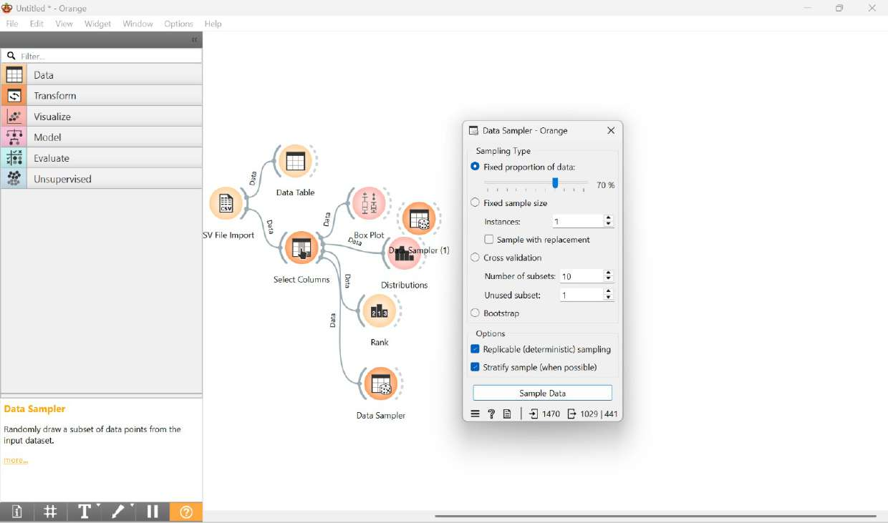
Figure 5.7: Data Sampler configuration showing the 70 / 30 split.
Two options were enabled. Replicable sampling fixes the random seed so that the same split is produced on every run, allowing the results reported here to be reproduced exactly. Stratified sampling preserves the original proportion of leavers and stayers in both subsets, so the 16 per cent attrition rate is not accidentally concentrated in one half.

6.6 Logistic regression model configuration
Attrition takes one of two values (Yes or No), so the task is binary classification. Linear regression predicts a continuous number and is not appropriate here. Logistic regression predicts the probability that an employee belongs to the attrition class, which is what the business question requires.
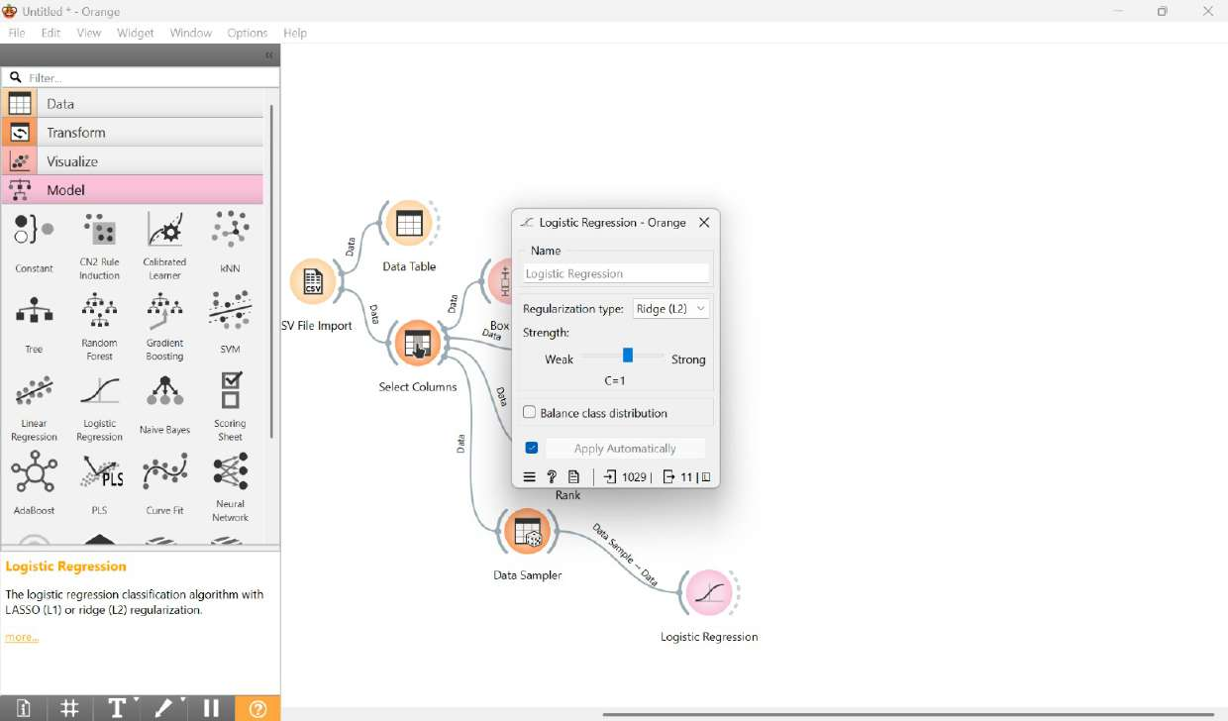
Figure 5.8: Logistic Regression widget settings used for the baseline model.
The model was fitted with Ridge (L2) regularisation at strength C = 1. Regularisation constrains the size of the coefficients, preventing the model from overfitting the training data and helping it generalise to employees it has not seen. Class balancing was left switched off for this baseline model. Section 5.13 reports what happens when it is enabled.

6.7 Prediction output
The Predictions widget applied the trained model to the 441 held-back employees. For each one, it returns a probability of staying, a probability of leaving, the predicted class, and an error value indicating how far the prediction is from the recorded outcome.
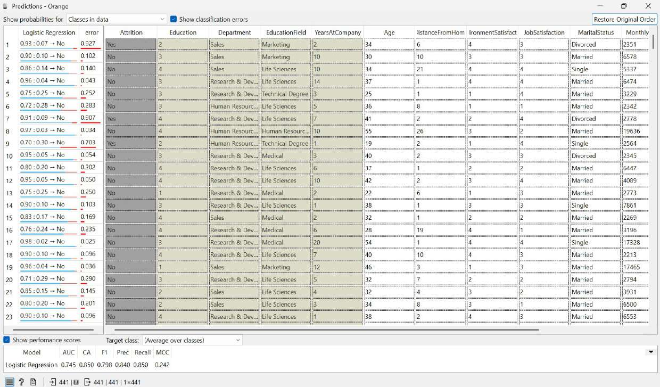
Figure 5.9: Predictions widget output with performance scores averaged over both classes.
Reading individual rows shows the model working sensibly on clear cases and struggling on ambiguous ones. Employee 4 was assigned a 96 per cent probability of staying and did stay, an error of 0.043. Employee 1, a divorced Sales employee aged 34 earning 2,351 with 2 years at the company, was given a 93 per cent probability of staying, but had in fact left, resulting in an error of 0.927. Cases like this one are the source of the recall problem discussed below.

6.8 Model performance
Orange calculates performance either by averaging across both classes or by a single target class. Both views are reported here because they lead to very different impressions of the same model.
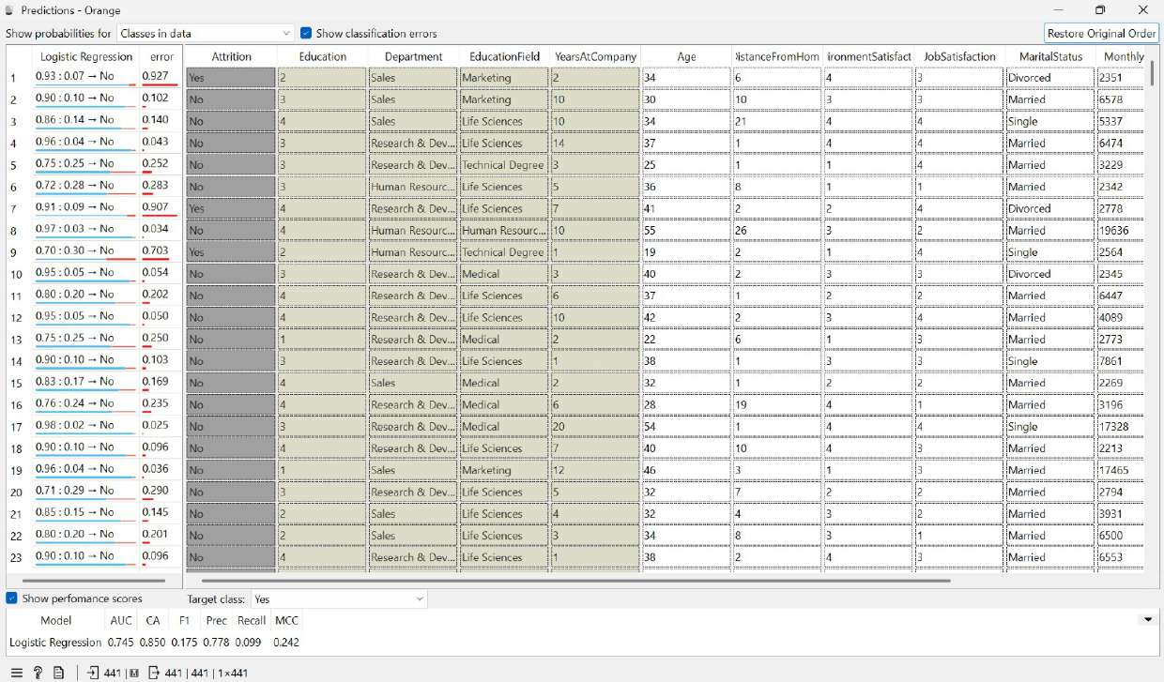
Figure 5.10: The same predictions evaluated with the target class set to Yes.
Metric | Average over classes | Target class = Yes | What it measures
AUC | 0.745 | 0.745 | Ability to separate leavers from stayers
Classification accuracy | 0.850 | 0.850 | Share of all correct predictions
F1 score | 0.798 | 0.175 | Balance of precision and recall
Precision | 0.840 | 0.778 | Share of flagged employees who truly left
Recall | 0.850 | 0.099 | Share of actual leavers that the model identified
MCC | 0.242 | 0.242 | Correlation between prediction and outcome
Table 5.4: Baseline model performance under both evaluation settings.
The averaged column suggests a strong model. The accuracy of 85 per cent and the recall of 0.850 both look convincing. Switching the target class to Yes changes the picture entirely: recall falls to 0.099, and the F1 score drops from 0.798 to 0.175.
The model itself has not changed between these two views. Only the question being asked has changed. Averaged metrics blend performance on both classes, and since 84 per cent of employees stayed, the model’s strong performance on that majority dominates the average. Setting the target class to Yes asks the narrower question that the business actually cares about: of the employees who genuinely left, how many did the model catch? The answer is roughly one in ten.
This is the effect of class imbalance. With leavers accounting for only 16 per cent of the data, a model that predicted "No" for everyone would still achieve 84 per cent accuracy while identifying no one at risk. Accuracy alone is therefore a misleading measure for this problem, and AUC, recall, F1 and MCC carry more weight. The precision figure of 0.778 shows the opposite side of the same behaviour: when the model does flag someone as a leaver, it is usually right, but it flags very few people.

6.9 Confusion matrix
The confusion matrix breaks the 441 test predictions into correct and incorrect outcomes for each class, showing exactly where the recall problem lies.
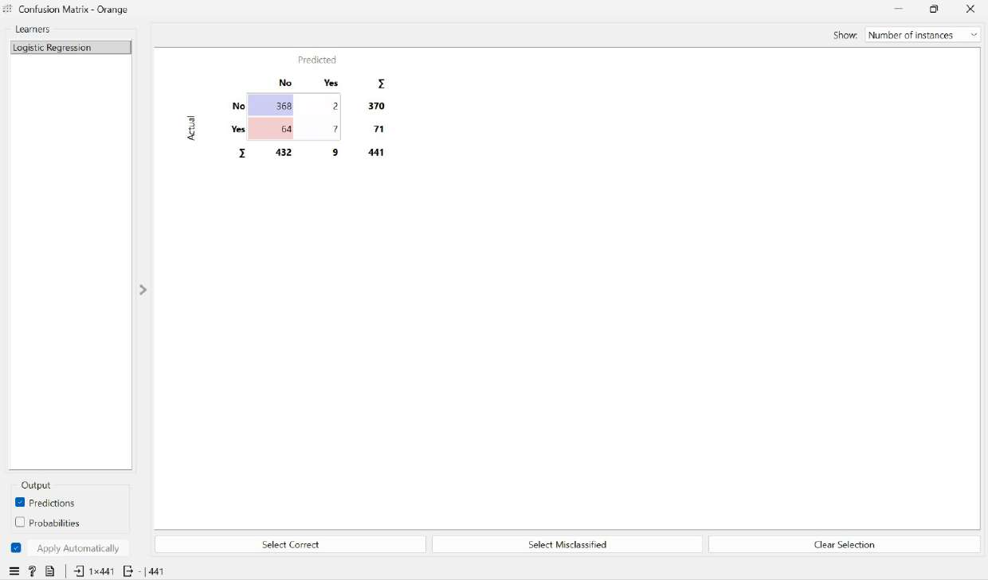
Figure 5.11: Confusion matrix showing the number of instances in each cell.

Actual outcome | Predicted: No | Predicted: Yes | Total
Stayed (No) | 368 | 2 | 370
Left (Yes) | 64 | 7 | 71
Total | 432 | 9 | 441
Table 5.5: Confusion matrix for the baseline model on the 441 test records.

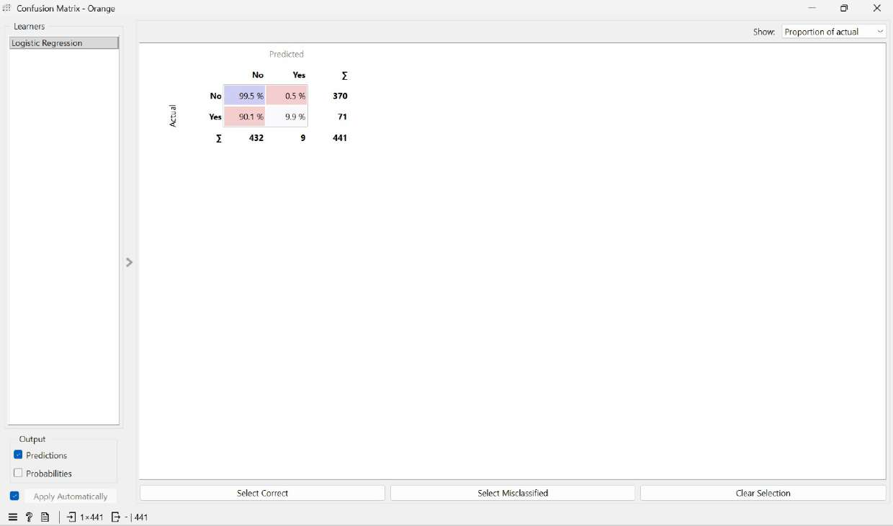
Figure 5.12: The same matrix expressed as a proportion of actual outcomes.
The proportional view states the problem plainly. Among employees who stayed, 99.5 per cent were classified correctly. Among employees who left, only 9.9 per cent were identified, while 90.1 per cent were predicted to stay.
The 64 employees in the lower left cell are the costly errors. Each one left the organisation while the model indicated no risk, so that no retention action would have been triggered. The two employees in the upper-right cell are the opposite of the error: flagged as at risk, but they stayed. The cost of these two error types is not symmetric. A false alarm leads to an unnecessary conversation with an employee who was not going to leave. A missed leaver leads to a resignation, a vacancy, and the full cost of recruitment and retraining. A model that produces 64 misses to avoid 2 false alarms is optimising the wrong way round for this business problem.

6.10 ROC curve analysis
Accuracy and recall are measured at a single decision threshold, the default probability cut-off of 0.5. The ROC curve evaluates the model across all possible thresholds, separating the model's performance from the choice of cutoff.
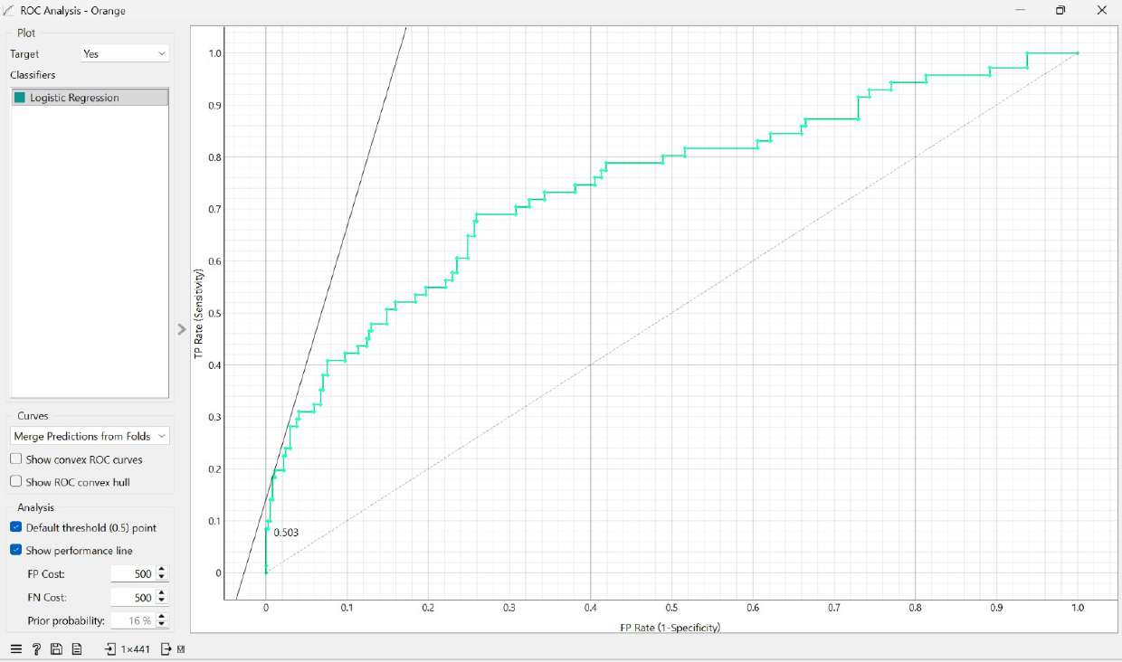
Figure 5.13: ROC curve with the target class set to Yes.
The curve sits above the diagonal reference line across its full length, so the model ranks employees better than random guessing would. The AUC of 0.745 means that if one leaver and one stayer are drawn at random, the model assigns the leaver a higher attrition probability about 75 per cent of the time. For HR data, this is a reasonable level of discrimination.
The number printed on the curve, 0.503, marks the default threshold point rather than the AUC, and the two should not be confused when reading the figure. The same curve, viewed with the target set to No, is shown below for completeness; it describes the same model from the perspective of the majority class.
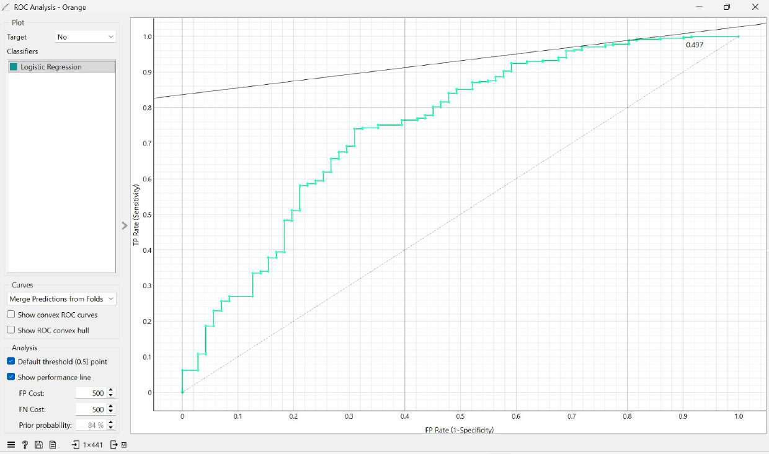
Figure 5.14: ROC curve with the target class set to No.
The gap between an AUC of 0.745 and a recall of 0.099 is the important observation here. The model ranks employees by risk quite competently, but the default 0.5 threshold is set too high for a minority outcome, so very few employees ever cross it. The problem lies in the threshold, not in the underlying model.

6.11 Coefficient analysis
The coefficient table gives the direction and size of each variable’s effect on the log odds of attrition. A positive coefficient increases the probability that an employee leaves; a negative coefficient reduces it.

Figure 5.15: Logistic regression coefficients for the attrition class.
Variable | Coefficient | Direction | Interpretation
Marital Status = Single | +0.554 | Increases attrition | The strongest single risk factor in the model
Num Companies Worked | +0.099 | Increases attrition | Each previous employer raises the risk
Distance From Home | +0.031 | Increases attrition | Longer commutes raise the risk
Age | -0.039 | Reduces attrition | Older employees are less likely to leave
Monthly Income | -0.000099 | Reduces attrition | Small per unit value, large across the salary range
Work-Life Balance | -0.233 | Reduces attrition | Each point on the scale lowers risk
Job Satisfaction | -0.305 | Reduces attrition | Strong protective effect
Environment Satisfaction | -0.306 | Reduces attrition | Strong protective effect
Marital Status = Married | -0.108 | Reduces attrition | Relative to the model baseline
Marital Status = Divorced | -0.445 | Reduces attrition | Lowest risk marital category
Intercept | +1.877 | Baseline | Model constant, not an employee attribute
Table 5.6: Logistic regression coefficients, grouped by direction of effect.
Marital status produces the widest spread in the model. Single employees have a coefficient of +0.554, while divorced employees have a coefficient of -0.445, a difference of almost exactly 1 unit of log odds between the two categories.
The two satisfaction measures behave almost identically, at -0.305 and -0.306, and Work-Life Balance follows closely at -0.233. These three are the variables the organisation can most directly influence, which makes their strength useful rather than merely interesting.
The Monthly Income coefficient of -0.000099 appears negligible until scaled. The coefficient applies to every single unit of salary, so across a difference of 5,000 per month, it amounts to roughly half a unit of log odds, comparable in size to the marital status effect. Small coefficients on wide-ranging variables should not be dismissed based on raw numbers alone.
Job Satisfaction and Distance from Home, the two low-ranking variables retained in section 5.4, both behave as expected in the fitted model. Job Satisfaction turns out to be among the strongest protective factors, which supports keeping it despite its ninth-place ranking.

6.12 Nomogram interpretation
The Nomogram presents the same coefficients visually, ordered by absolute importance, and allows the contribution of each variable to be read off a scale.
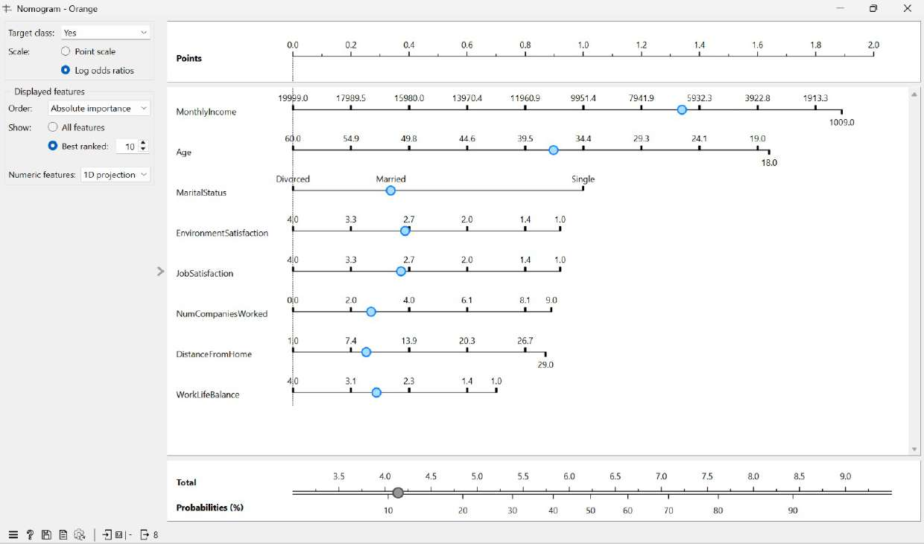
Figure 5.16: Nomogram for the attrition class, ordered by absolute importance.
Reading the scales from left to right shows the direction of risk for each variable. Monthly Income runs from 19,999 at the low-risk end to 1,009 at the high-risk end. Age runs from 60 down to 18. Marital Status places Divorced at the low-risk end and Single at the high-risk end. The satisfaction scales and Work-Life Balance run from 4 at the protective end to 1 at the risk end, while Num Companies Worked and Distance from Home run in the opposite direction, with higher values indicating greater risk.
The lower portion of the figure converts a total score into a probability. This is what makes the nomogram practical for HR use: an individual employee’s attributes can be located on each scale and combined to estimate the probability of leaving, without running the model or reading the coefficient table.

6.13 Improving detection through class balancing
Sections 5.8 to 5.10 established that the baseline model ranks employees well but identifies too few actual leavers due to class imbalance. Enabling the Balance class distribution option in the Logistic Regression widget instructs the model to weight the minority class more heavily during training, so that missing a leaf is treated as a more serious error than raising a false alarm.
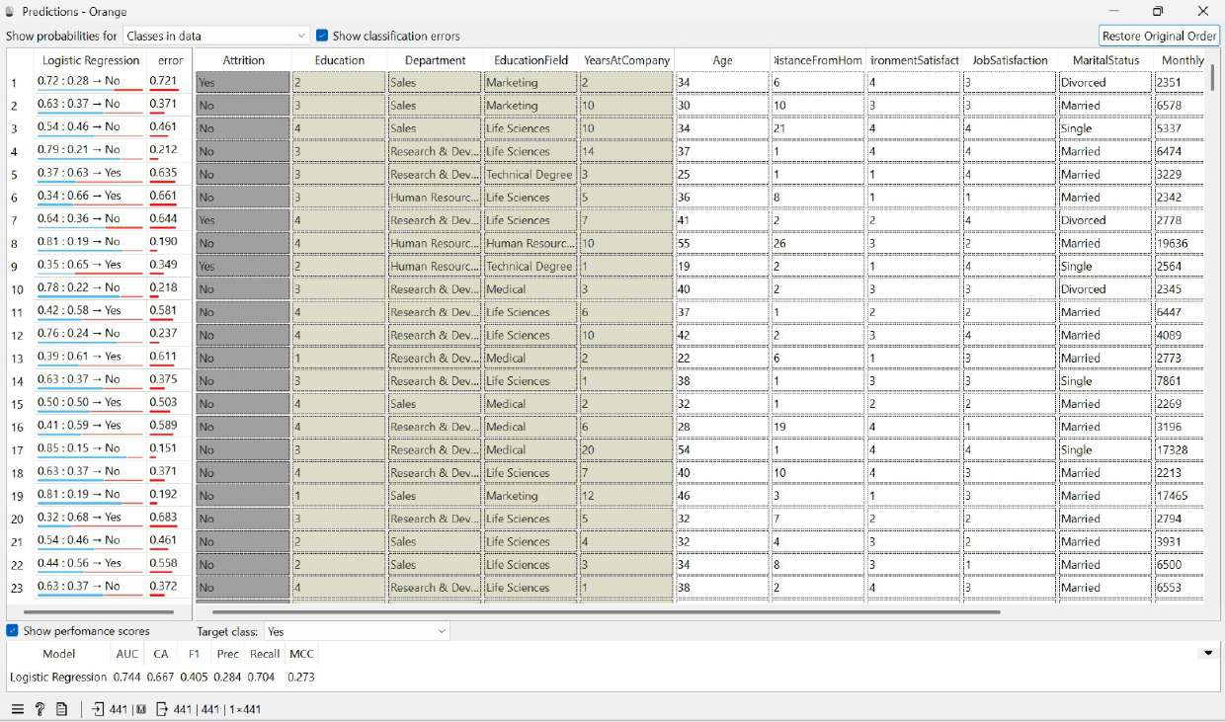
Figure 5.17: Predictions output after class balancing, with the target class set to Yes.
Metric | Baseline model | Balanced model | Change
AUC | 0.745 | 0.744 | Effectively unchanged
Classification accuracy | 0.850 | 0.667 | Down 18.3 points
F1 score | 0.175 | 0.405 | Up 0.230
Precision | 0.778 | 0.284 | Down 0.494
Recall | 0.099 | 0.704 | Up 0.605
MCC | 0.242 | 0.273 | Up 0.031
Table 5.7: Baseline and balanced model compared, both evaluated with the target class Yes.
Recall rises from 0.099 to 0.704. The balanced model identifies roughly 7 out of every 10 employees who actually left, compared with 1 in 10 for the baseline. The F1 score more than doubles, and MCC improves slightly.
The improvement is not free. Accuracy falls from 85.0 per cent to 66.7 per cent, and precision drops from 0.778 to 0.284, meaning that fewer than three in ten flagged employees will actually leave. In practice, the model now raises a considerably larger number of false alarms.
Notably, AUC barely moves, from 0.745 to 0.744. This confirms the point made in section 5.10: the model's underlying ability to rank employees by risk has not changed. Class balancing shifts the decision boundary rather than making the model fundamentally better at understanding attrition.
The preferred model depends on the relative costs of the two error types. A false alarm costs a manager a conversation with an employee who was not going to leave, which has little downside and may be useful in itself. A missed lever costs the organisation recruitment, onboarding, lost productivity and lost institutional knowledge. Given that asymmetry, the balanced model is the more appropriate choice for an HR early warning system, and it is the model on which the recommendations in the following section are based.

6.14 Summary of findings
The analysis yielded four findings that inform the recommendations.
Attrition in this organisation is driven by several factors acting together rather than by any single cause. The employees most likely to leave are single, younger, lower-paid, commuting longer distances, with a history of several previous employers, and reporting low satisfaction and poor work-life balance. None of these variables dominates the others.
Compensation shows the clearest and most reliably measured gap. Leavers earned on average 4,787, compared with 6,833 for those who stayed, a difference confirmed as statistically significant by the student’s t-test in the box plot analysis, and Monthly Income also ranked first among all 12 candidate predictors.
The three variables the organisation can most readily influence, namely Job Satisfaction, Environment Satisfaction and Work-Life Balance, all carry substantial protective coefficients. These represent the practical levers available to HR, as marital status and age cannot be managed.
The choice of evaluation metric shapes the model's assessment more than any modelling decision does. The baseline model reports 85.0 per cent accuracy yet identifies fewer than one in ten actual leavers. Balancing the classes raises detection to 7/10 at the cost of accuracy falling to 66.7 per cent, while AUC remains roughly 0.745 throughout. For a rare outcome such as attrition, accuracy is the least informative of the available measures, and recall, together with AUC, gives a far more honest account of whether the model is doing the job it was built for.
These results provide the evidence base for the retention recommendations set out in the next section.

7. Business Recommendations: Keeping Our Employees

7.1 Quick Summary
When employees leave unexpectedly, it costs the company a lot of money and slows down our work. Instead of just guessing why people quit, we used data to find the real reasons. By looking at these patterns, we can take specific actions to keep our team happy and stop them from leaving.

7.2. How Good is Our Data Tool?
To make sure our plan works, we tested our data model carefully to ensure it gives reliable results.
- Overall Accuracy: Our data tool has an overall accuracy of 66.7%.
- Predicting Who Might Leave: Our final model is very good at identifying who is at risk of quitting. It correctly guesses 70.4% of the employees who actually end up leaving. This means our HR team can step in and help with high confidence, rather than just guessing.
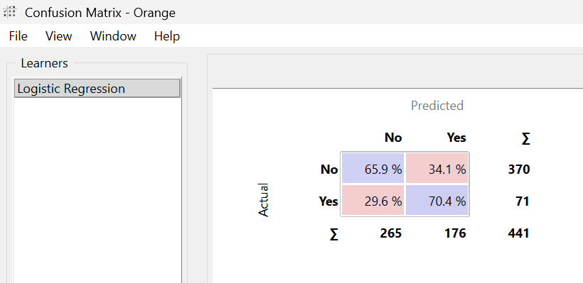

7.3. Main Reasons People Leave or Stay
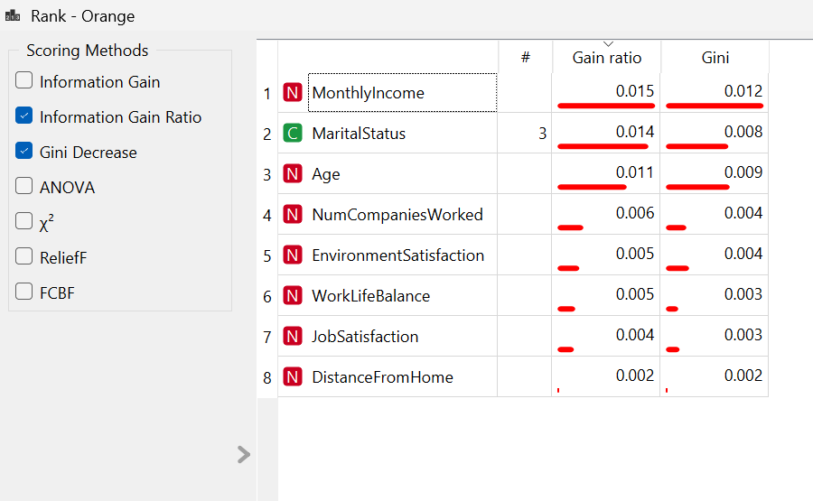
Our data showed clear patterns that separate the people who stay from the people who quit.

Why People Leave (Risk Factors):
- Being Single: This is the biggest demographic factor. Single employees are quitting much more often than married or divorced employees.
- Past Job Hopping: People who have worked at many different companies before coming to us are more likely to leave.
- Long Commutes: Living far away from the office makes people want to quit.
Why People Stay (Keeping Factors):
- Happiness at Work: Employees who are happy with their work environment and their specific job are much more likely to stay. This is our strongest tool for keeping people.
- Work-Life Balance: Having enough time for personal life outside of work keeps people around.
- Age and Pay: Older employees and those who make more money are less likely to quit.

7.4. Action Plan: What We Should Do
To fix the specific problems our data found, HR should take these steps:
- Keep Single & Mobile Workers Engaged: Since single employees and past job-hoppers get bored easily and leave, we need to give them new challenges, special projects, and clear ways to grow their careers here.
- Help with Long Commutes: To help people who live far away, we should let them work from home on certain days if their job allows it. If they have to come in, we could offer flexible hours so they don't have to drive during rush hour traffic.
- Check on Happiness More Often: Since being happy at work is the best way to keep people, we shouldn't wait for a yearly survey. We should ask employees how they are doing every few months so managers can fix small problems before they become big ones.
- Protect Personal Time: Make sure people are not working too much after hours, and watch out for teams that are working too hard to prevent burnout.
- Review Pay Regularly: Check salaries often to make sure our best workers are paid fairly. We should do this before their yearly review, especially for people who are at a higher risk of leaving.

7.5. Next Steps
- Right Away (0-30 Days): Managers should have friendly "stay interviews" (checking in to see how things are going) with top workers who have high risk factors, like a really long commute.
- Soon (1-3 Months): Start testing new work-from-home rules and send out the first quick survey to check how happy people are with their work environment.
- Later (6+ Months): Add this data tool to our main HR computer system so HR can always see who might need extra support.

8. Conclusion & Limitations

Summary
Using Logistic Regression within Orange, this study identified the key drivers of employee attrition at IBM. The optimized model achieves an AUC of 0.745, a sensitivity (Recall) of 85.03% and Precision of 84.%. Attrition is primarily driven by marital status, commute distance, monthly income, age, prior job mobility, work-life balance and workplace/job satisfaction.

Limitations
Unobserved External Factors: Key external drivers such as regional economic conditions, competitor hiring offers, and specific manager performance metrics are not captured in the dataset.
Cross-Sectional Scope: The data reflects a single point-in-time snapshot rather than tracking across multiple financial quarters.
Class Imbalance: Attrition cases represent 16.12% of total observations. While enabling balance class distribution improves detection

9. References

IBM attrition dataset: https://www.kaggle.com/datasets/yasserh/ibm-attrition-dataset

Masai Data Analytics, GenAI & Execution from IIM Sirmaur Lectures and study materials

